University of Phoenix Material

Understanding the Business Side of Health Care

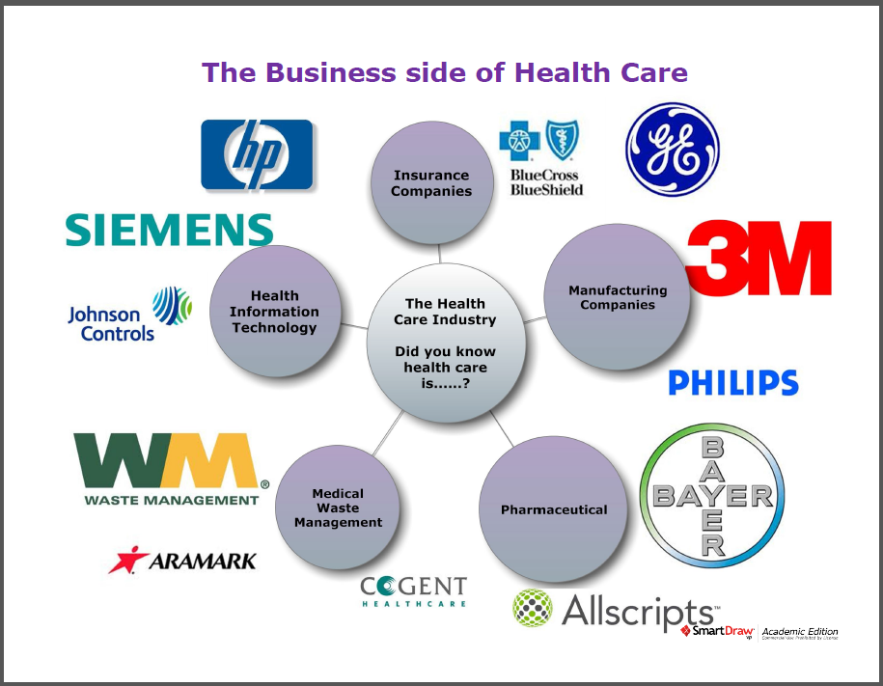
The Business Side of Health Care infographic was created to show individuals how different entities contribute to the health care industry. For a long time most people assumed you were talking about doctors and nurses, i.e., the clinical aspect of health care, when discussing health care. As you complete this course and many others in your degree, it will be important to remember that there is a business side to health care that interacts with different entities to make the health care industry successful. As such, it is helpful if you remember that health care is an industry.
Review the Business Side of Health Care infographic.
Provide your own example of a company that contributes to each of the major health care entities listed in the infographic. Describe how the company contributes to the identified health care entity.
Health Care Entity | Example of Company | Company’s Contribution
Example: Insurance Companies | Aetna | Aetna provides health care insurance and coverage, products, and services to individuals and families, employers and organizations, health care professionals, and producers.
Health Information Technology
Pharmaceutical
Medical Waste Management
Manufacturing Companies

Identify at least two additional health care entities that could be represented in the infographic.
Health Care Entities | Describe why this entities can be represented in the infographic
Example: Architecture and Interior Design Firms (facility design) | Facility design firms provide products and services to different health care facilities that are planning to build new or redesign their current building space. They fit within this infographic because the designers need to understand medical terminology and health care concepts to build an effective space for their health care clients.
1.
2.
*Note: Two additional lines are added for students to provide additional entities if they feel it is necessary.

